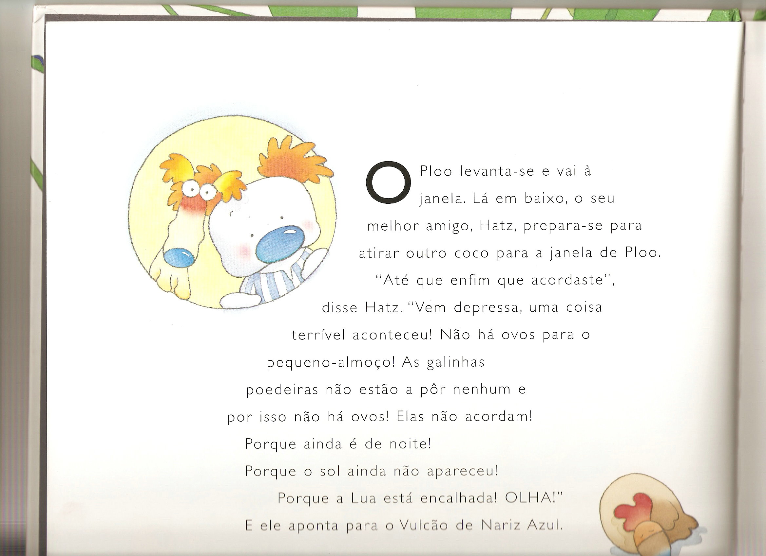
A ilha dos Narizes Azuis

Relembrem a história e com cuidado registem o seguinte:

Qual o título do livro | Onde se passa a história. | Quem são as personagens da história.

Como são as personagens | Que problema aconteceu na história.

Como foi resolvido o problema da história

Apresentem oralmente o trabalho realizado à turma.

Agora verifiquem se se esqueceram de alguma coisa e tentem construir o resumo da história.

A ilha dos Narizes Azuis

Resumo da história.

________________________________________________________________________________________________________________________________________________________________________________________________________________________________________________________________________________________________________________________________________________________________________________________________________________________________________________________________________________________________________________________________________________________________________________________________________________________________________________________________________________________________________________________________________________________________________________________________________________________________________________________________________________________________________________________________________________________________________________________________________________________________________________________________________________________________________________________________________________________________________________________________________________________________________________________________________________________________________________________________________________________________________________________________________________________________________________________________________________________________________________________________________________________________________________________________________________________________________________________________________________________________________________________________________________________________________________________________________________________________________________________________________________________________________________________________________________________________________________________________________________________________________________________________________________________________________________________________________________________________________________________________________________________________________________________________________________________________________________________________________________________________________________________________________________________________________________________________________________________________________________________________________________________________________________________________________________________________________________________________________________________________________________________________________________________________________________________________________________________________________________________________________________________________________________________________________________________________________________________________________________________________________________________________________________________________________________________________________________________________________________________________________________________________________________________________________________________________________________________________________________________________________________________________

