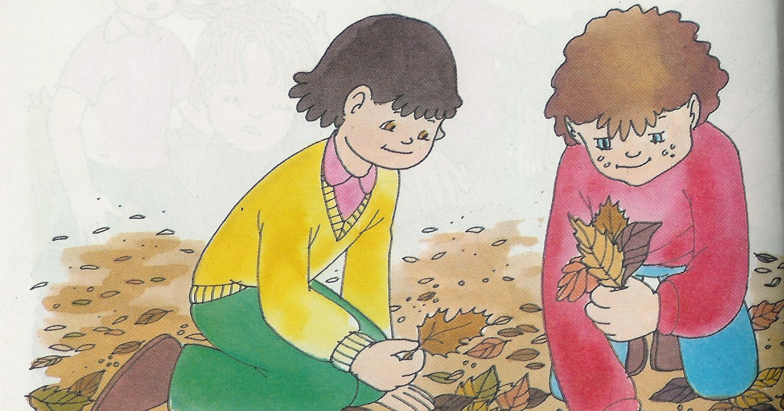

Escola n.º 3 de Peniche

Expressão Escrita

 | Onde estão? | Como são? | O que fazem?
Meninos | _____________________  _____________________  _____________________ | _____________________  _____________________  _____________________ | _____________________  _____________________  _____________________
Folhas | _____________________  _____________________  _____________________ | _____________________  _____________________  _____________________ | _____________________  _____________________  _____________________

- Junta as ideias e imagina uma história, a mais linda que souberes. Dá-lhe um título.
______________________________________
________________________________________________________________________________________________________________________________________________________________________________________________________________________________________________________________________________________________________________________________________________________________________________________________________________________________________________________________________________________________________________________________________________________________________________________________________________________________________________________________________________________________________________________________________________________________________________________________________________________________________________
Nome ________________________________________________ Data ____-____-______

