O meu Carnaval
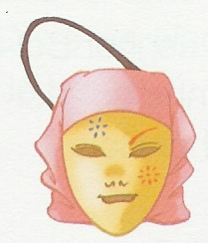

Num bonito texto, conta como viveste as tuas férias de Carnaval.

_____________________________________________________________________________
___________________________________________________________________________________________________________________________________________________________________________________________________________________________________________________________________________________________________________________________________________________________________________________________________________________________________________________________________________________________________________________________________________________________________________________________________________________________________________________________________________________________________________________________________________________________________________________________________________________________________________________________________________________________________________________________________________________________________________________________________________________________________________________________________________________________________________________________________________________________________________________________________
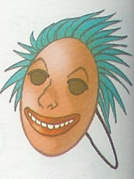
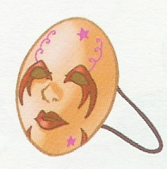

Expressa, através de um desenho, o que mais gostaste neste Carnaval.
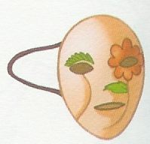

Nome ________________________________________________________ Data ___/____/______

ESCOLA BÁSICA N.º 3 DE PENICHE
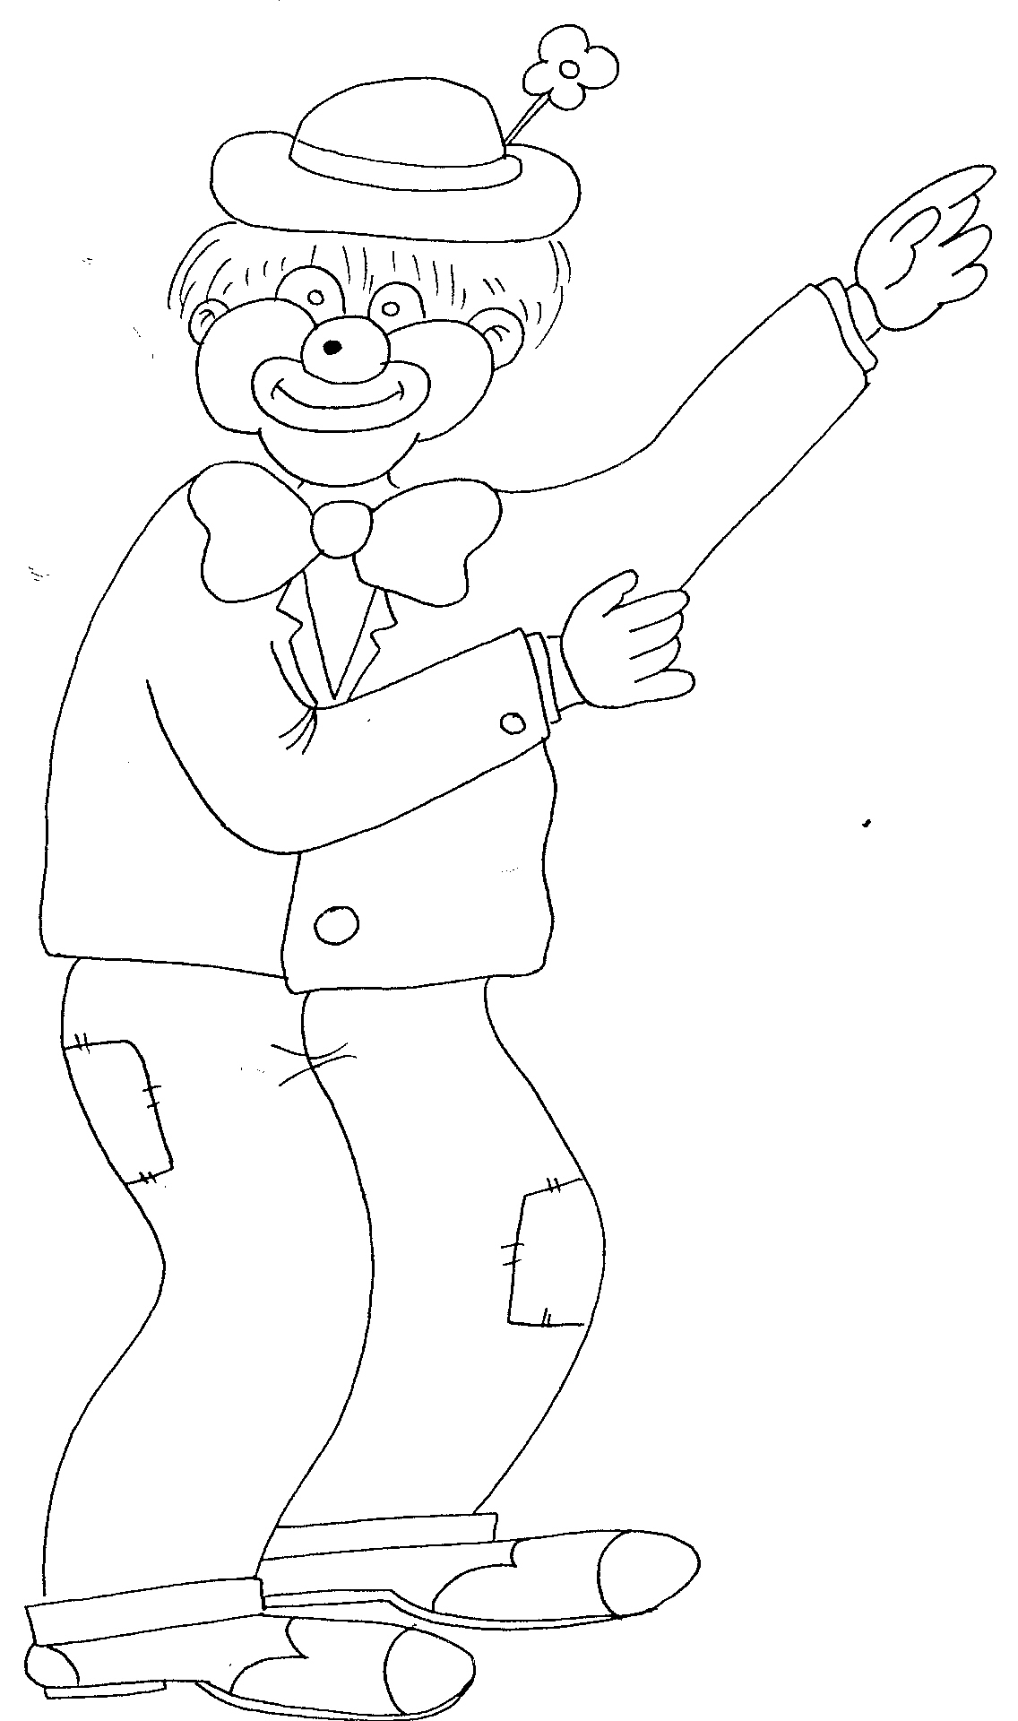

Vamos construir a área vocabular de Carnaval
Nome ____________________________________________________________ Data ___/___/______

