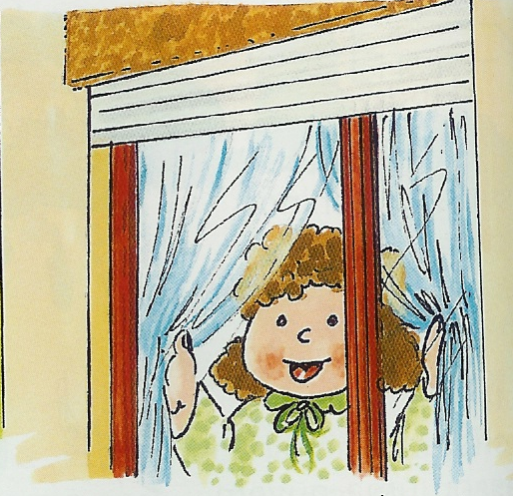

Imagina o que se teria passado que levou a menina a ir à janela e depois... o que terá ela visto?
Não esqueças de lhe dar um nome, de escrever e ilustrar tudo muito bem.
______________________________________________________________________________________________________________________________________________________________________________________________________________________________________________________________________________________________________________________________________________________________________________________________________________________________________________________________________________________________________________________________________________________________________________________________________________________________________________________________________________________________________________________________________
_______________________________________________________________________________________________________________________________________________________________________________________________________________________________________________________________________________________________________________________________________________________________________________________________________________________________________________________________________

