Nome:______________________________________Data:_________________

Lê e copia as frases. Ilustra.

1-O Mário vive numa casa junto à sua escola.
__________________________________________

2-Quando chegamos a Dezembro o tempo arrefece.
____________________________________________

3-Em Novembro comemoramos o São Martinho, comendo castanhas cozidas ou assadas.
___________________________________________________________

1 | 2 | 3

Escreve algumas frases sobre as seguintes imagens

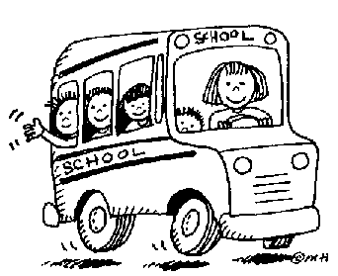 | __________________________________________________  __________________________________________________  __________________________________________________  __________________________________________________
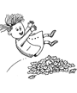 | __________________________________________________  __________________________________________________  __________________________________________________  __________________________________________________
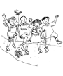 | __________________________________________________  __________________________________________________  __________________________________________________  __________________________________________________
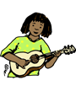 | __________________________________________________  __________________________________________________  __________________________________________________  __________________________________________________
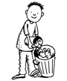 | __________________________________________________  __________________________________________________  __________________________________________________  __________________________________________________
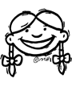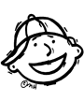 | __________________________________________________  __________________________________________________  __________________________________________________  __________________________________________________
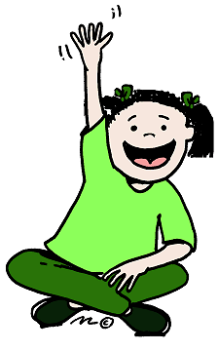 | __________________________________________________  __________________________________________________  __________________________________________________  __________________________________________________

Ordena as frases:

saúde bem fazem Os pêssegos à
______________________________________________________

sol No fraco tem brilho um Outono o
______________________________________________________

sorrir A Fátima de gosta dançar e
______________________________________________________

Divide em sílabas:
Tambor-_____________ guitarra- _________________
Piano- ______________ harpa-____________________
Violino-______________ pandeireta-_________________

