DATA: __________ de _____________________________ de 2006

NOME: _________________________________________________________

1. Legenda as imagens e desenha.

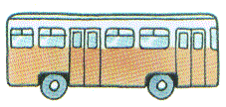 |  | 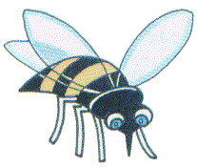 | 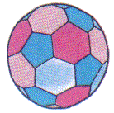
 | caneta
 |  |  | 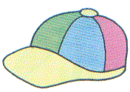
janela |  | giz

2. Lê e copia as frases.

É a abelha. ___________________________________________________

A abelha voa. ___________________________________________________

A Abelha é amarela e preta. ________________________________________

Eu sou a Filipa. __________________________________________________

A Filipa é professora. _____________________________________________

Eu sou o Yuri. ___________________________________________________

O Yuri é aluno. ___________________________________________________

Eu gosto do Yuri. _________________________________________________

Eu gosto de banana. ______________________________________________

3. Escolhe três palavras e escreve três frases pequenas.

____________________________________________________________________________________________________________________________________________________________________________________________

4. Escreve por extenso:
1 - ________
11 - ___________
12-____________
13-____________
14-____________
15-____________
16-____________
17-____________
18-____________
19-____________
20-____________

21 - _____________
22-______________
23-______________
24-______________
25-______________
26-______________
27-______________
28-______________
29-______________
30-______________

40 - _____________
50-______________
60-______________
70-______________
80-______________
90-______________
100-_____________

2- _________
3-__________
4-__________
5-__________
6-__________
7-__________
8-__________
9-__________
10-_________

Completa com o nome das cores.

 ______________  ______________

 ______________  ______________

 ______________  ______________

 ______________  ______________

 ______________  ______________

