Expressão Escrita
Nome ________________________________________________ Data ___/___/____

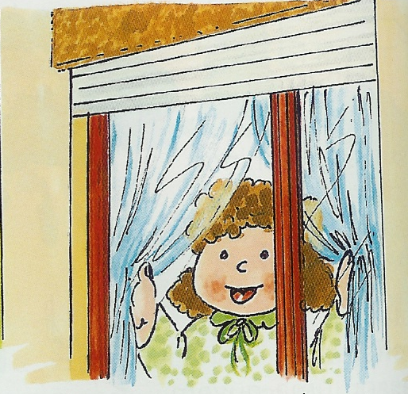

Melhoramento de Texto

Quem? ______________________
Quando? ____________________
Onde estava?_________________
____________________________
O que fez? ___________________
____________________________
Porquê? _____________________
________________________________________________________

______________________________________
___________________________________________________________________________________________________________________________________________________________________________________________________________________________________________________________________________________________________________________________________________________________________________________________________________
_________________________________________________________________________________________________________________________________________________________________________________________________________________________________________________________________________________________________________________________________________________________________________________________________________________________________________________________________________________________________________________________________________________________________________________________________________________________________________________________________________________________________________________________________________________________________________________________________________________________________________________________________________________________________________________________________________________________________________________________________________________________________________________________________________________________________________________________________________________________________________________________________________________________________

