ENUMERA NA SEQUÊNCIA CORREcTA E CONTA A HISTÓRIA

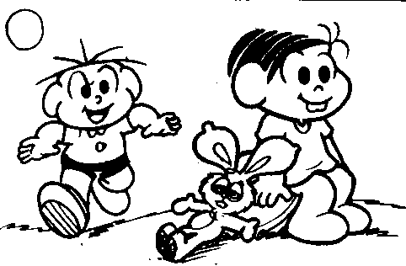 | 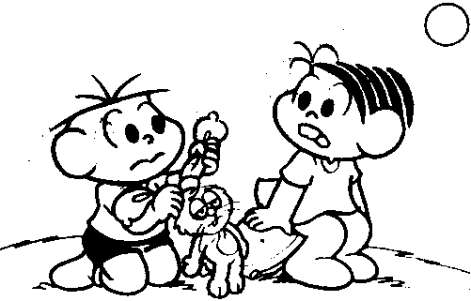
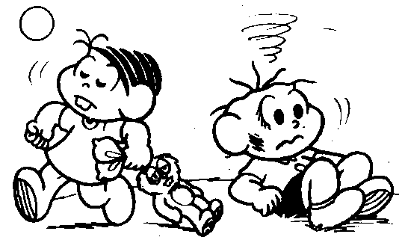 | 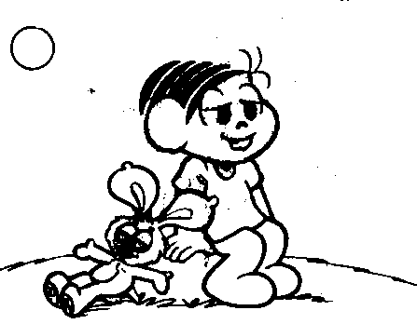

____________________________
____________________________________________________________________________________________________________________________________________________________________________________________________________________________________________________________________________________________________________________________________________________________________________________________________________________________________________________________________________________________________________________________________________________________________________________________________________________________________________________________________________________________________________________________________________________________________________________________________________________________________________________________________________________________________

ENUMERA NA SEQUÊNCIA CORREcTA E CONTA A HISTÓRIA

____________________________
_________________________________________________________________________________________________________________________________________________________________________________________________________________________________________________________________________________________________________________________________________________________________________________________________________________________________________________________________________________________________________________________________________________________________________________________________________________________________________________________________________________________________________________________________________________________________________________________________________________________
_____________________________________________________________

